Our Vision  To become the premier national and regional benchmark in leading the future of sustainable agricultural and livestock investment, and the most trusted brand in delivering ultra-pure, healthy food.  We aim to achieve this by transforming the Egyptian desert into smart, productive oases that implement the highest international standards for integrated organic production. |  |  |  |  | Green Pharaoh  An Oasis of Sustainable Production and Organic Bioregulation in the Heart of the Egyptian Desert  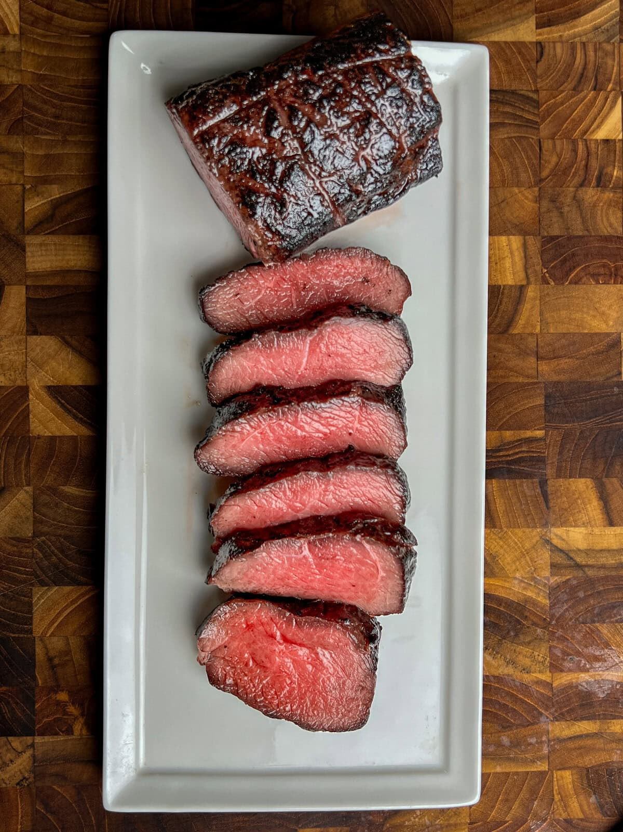

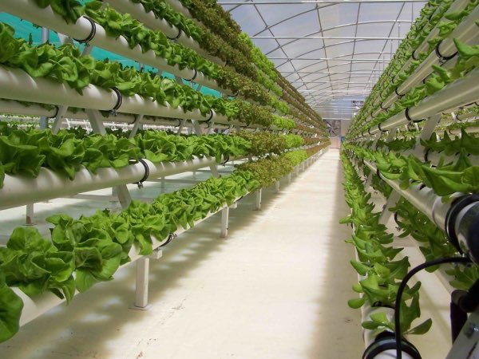  OurMission  To produce and provide a comprehensive, diversified portfolio of premium-quality agricultural, livestock, aquaculture, and healthy food products locally, relying entirely on a circular organic farming ecosystem. We are deeply committed to protecting natural resources, creating attractive urban communities for youth, and delivering sustainable added value that bolsters national food security while reducing import dependency. | “Your company is the greatest. I can’t imagine anyone living without you.”  - Very smart customer  StrategicObjectives  Supporting the National Economy and Reducing Imports  Providing premium-quality, luxury domestic alternatives for crops, meat, aquaculture, and bio-products (such as Ashwagandha, Stevia, and Spirulina), thereby contributing to lowering the state's import bill.  PioneeringOrganicProduction  Implementing 100% global organic food compliance standards on a comprehensive scale for the first time. This rigorous process spans from ensuring absolute soil and water purity to delivering the finished product to the consumer completely free from any chemical intervention.  Achieving Zero-Waste Operational Integration  Activating a comprehensive model of horizontal and vertical integration (Circular Economy) within the farm. This is achieved by recycling all agricultural and livestock outputs and waste to transform them into value-added production inputs, such as manufacturing self-sufficient feed and recycling palm wood by-products | SecuringSupplyChainIntegrity  Maintaining absolute control over product quality through an advanced logistical infrastructure that includes a semi-automated slaughterhouse, sorting and packaging complexes, and cold storage facilities, all backed by the company's dedicated refrigerated transport fleet to guarantee maximum freshness, health, and safety standards  EnvironmentalSustainabilityandCleanEnergy  Expanding the deployment of green technology, solar energy systems, and aquaponics techniques to optimize water and energy consumption while preserving biodiversity  HumanDevelopmentandDesertReclamation  Actively contributing to the National One and a Half Million Feddan Reclamation Project by creating over 500 sustainable employment opportunities for Egyptian youth, and providing a premium, fully serviced residential environment that motivates stability and productivity within these newly established communities
ll

General Introduction & Project Founding  Green Pharaoh was established in 2025 as a strategic response and practical implementation of Egypt's National One and a Half Million Feddan Reclamation Project. The enterprise was launched with an ambitious national vision aimed at pioneering and reclaiming the desert, transforming virgin lands into sustainable, productive communities that contribute to redefining the concept of food security.  The company owns and operates an integrated, multi-activity, and multi-product model farm in the Moghra region, south of El Alamein City—one of Egypt's most promising zones for smart agricultural investment. The farm is distinguished by applying a model of "horizontal and vertical integration" along with the principle of "value-added production." Within this framework, no production input is wasted; rather, every component is recycled to become a primary input in a subsequent production cycle, thereby achieving a zero-waste circular economy model. |  | 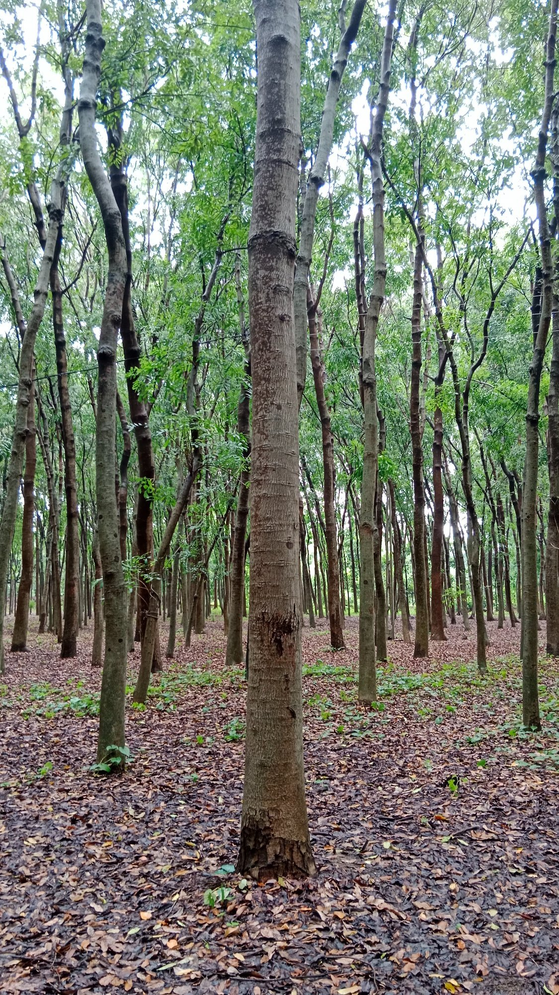 | Production Philosophy and Global Organic Requirements  Green Pharaoh strictly adheres to organic food compliance standards (the fully integrated biological ecosystem) for the first time on a rigorous and comprehensive scale in alignment with international benchmarks. The company's core vision focuses on producing 100% pure and healthy food locally, thereby reducing the import burden and boosting the national economy. These standards encompass:  • Regular Soil Inspection: Conducting periodic testing to verify soil purity and ensure its natural clearance from any historical chemical residues.  • Pure Irrigation Water: Relying exclusively on pure, filtered irrigation water that is completely free from industrial contaminants or sewage pollutants.  • Absolute Prohibition of Chemicals: Enforcing a strict, categorical ban on the use of any chemical pesticides, fertilizers, hormones, or genetically modified organisms (GMOs), while substituting them with biological and natural solutions derived from the farm's internal ecosystem.
Operational Structure & Livestock Sector  Sector I: Feed Systems, Livestock Production, and Fattening & Dairy Breeds  - Self-Sufficient Forage Crop Unit: The farm features vast expanses dedicated to cultivating various types of forage crops, including both fresh green fodder and dry forage.  - Integrated Feed Mill: Harvested forage crops are routed directly as primary inputs into the farm's advanced feed processing unit. Here, they are manufactured into bio-processed, high-nutritional-value finished feed, completely free from chemical additives, to supply all livestock and poultry sectors within the project.  - Cattle and Livestock Barns: This section includes stations equipped with state-of-the-art care systems for raising dairy cows to produce pure milk, alongside independent calf fattening units. These operations rely exclusively on premium global breeds renowned for high feed conversion rates and strong disease resistance. | - Diversified Livestock Sector:  • Barki Sheep Barns: Dedicated to producing the finest types of mutton, celebrated for its purity and unique flavor profile.  • Shami (Damascus) Goat Barns: For the production of high-quality meat and dairy.  - Premium and Exotic Animal & Poultry Farms:  • African Ostrich Farm: For the production of premium red meat, feathers, and natural oils.  • European Deer Farm: A specialized production line targeting luxury hospitality sectors and niche specialized markets.  Poultry & Aquaponics Sectors  Sector II: Integrated Poultry, Avian Complex, and Related Activities  This sector features thermally insulated barns equipped with automated ventilation and feeding systems, divided into:  Poultry Fattening Barns: Dedicated to producing organic white and Baladi (local) chicken meat.  • Layer (Egg-Laying) Barns: For the production of healthy table eggs |  |  | completely free from hormones and antibiotics.  • Waterfowl and Wild Fowl Sector: Comprising independent units for breeding (European Geese, Muscovy Ducks, Royal Quail, and French Meat Pigeons—distinguished by high productivity).  • Rabbit Sector: Specialized barns for breeding and fattening pure rabbit strains.  • Peacock Sector: A section dedicated to breeding luxury ornamental birds.  Sector III: Marine & Freshwater Aquaculture and "Aquaponics" Greenhouses  - Aquaponics Greenhouses: A sophisticated, fully integrated system bridging the aquaculture and plant sectors. Nutrient-rich water generated from the fish ponds is utilized to fertilize, specialized greenhouses for organic
fresh vegetable production (such as leafy greens, tomatoes, and cucumbers). Concurrently, the plants naturally filter the water, returning it completely purified to the fish ponds.  - High-Value Aquatic Organisms: This advanced ecosystem enables the production of rare and economically high-value marine species, such as Freshwater Eels (Thabaan El-Samak) and Sole Fish (Samak Moussa)  Superfoods, Bio-Products & Dates Sector  Sector IV: Bio-Products, Premium Superfoods, and Luxury Dates  - Medicinal Plants and Superfoods Processing Unit: An advanced manufacturing complex dedicated to drying and processing natural bio-products and healthy organic supplements, including:  • Pure "Ashwagandha" powder.  • Pure natural sweet extract from the "Stevia" plant, serving as a healthy, zero-calorie sugar alternative.  • Dried, high-protein, nutrient-rich "Spirulina" algae powder. | - Specialized Food and Dairy Production Units:  • Mushroom Production Unit: Specialized facilities for cultivating various types of mushrooms.  • Microgreens Production Unit: Dedicated to cultivating young, highly concentrated nutrient-packed green seedlings.  • Pure Honey Bee Unit: Utilizing wild apiaries that forage exclusively on the farm's organic blossoms  - Integrated Dairy Processing Plant: A modern facility for receiving fresh milk from the farm's livestock sector and processing it into premium natural cheeses, yogurt, and butter in accordance with the highest food safety and quality standards.  - Premium Palm and Luxury Dates Sector: Vast reclaimed expanses cultivated with the finest palm tissue cultures to produce high-value luxury dates for both domestic consumption and international export, featuring:  - Barhi Dates.  - Medjool Dates. |  |  | Forestry, Infrastructure&Logistics  Sector V: Sustainable Agroforestry and Wood Processing & Manufacturing  In alignment with environmental sustainability principles, the farm features dedicated expanses for cultivating rare timber trees capable of withstanding harsh climate conditions while serving as natural windbreaks, such as African Mahogany and Sudanese Casuarina. These forests are integrated with manufacturing units that include:  • Timber Processing Unit: Dedicated to processing and cutting timber harvested from the trees.  Innovative Wood Production Line: An advanced line specializing in manufacturing
- composite wood from secondary palm by-products and reinforced agricultural residues, opening new horizons in the eco-friendly furniture and green construction industries.  Infrastructure, Logistics, and Supply Chain (From Farm to Consumer):  To ensure the preservation of premium quality and prevent any product contamination or damage during handling, Green Pharaoh has invested in constructing a fully integrated logistical infrastructure within the project site,  which includes:  • Semi-Automated Slaughterhouse: A modern slaughtering and processing complex that fully complies with strict sanitary and food safety requirements, dedicated to preparing meat from all types of livestock, poultry, and specialized animals produced on the farm.  Logistics, Supply Chain  • Processing, Sorting, and Packaging Unit: Automated production lines designed for sorting vegetables, aquaculture products, and dietary supplements, utilizing hygienic thermal sealing to preserve their full nutritional value.  • Warehouses and Cold Storage Facilities: A massive refrigeration and freezing complex featuring advanced cold storage units to strictly maintain the cold chain integrity for all | food products, meat, and dairy.  • Refrigerated Transport Fleet: The company operates its own dedicated fleet of refrigerated trucks and cargo vehicles equipped with digital climate-control systems. This ensures the direct transport of products from the heart of Moghra in El Alamein to distribution outlets  and end consumers in the shortest possible time, guaranteeing maximum freshness, health, and safety standards.  CorporateSocial Responsibility (CSR) and Human Capital Development  The vision of Green Pharaoh transcends standard agricultural and livestock production; it extends to acting as a core partner in community development and desert reclamation through:  • Creating direct and sustainable employment opportunities for more than 500 young Egyptian men and women across various disciplines (including agricultural engineers, veterinarians, production technicians, accountants, and specialized labor). |  |  | • Providing a fully integrated, self-contained residential community that offers premium housing, recreational amenities, and essential  living services for all on-site personnel. This stems from the management’s firm belief that fostering a stable, motivating environment for human capital is the foundational pillar for ensuring the success and long-term sustainability of this colossal national enterprise.
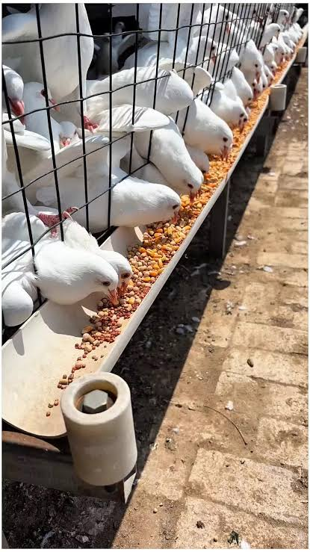 | Contact Us  Head Office: 4 Ali Fakhry St., Saba Pasha, Alexandria, Egypt, 21531  Telephone: 002035845441 /2/3/4/5  Site: Plot No. 945, Petroleum Road, Moghra Region, South of New El Alamein City, Egypt, 51716  Telephone: 0020463324461 /2/3/4/5  Email : pharaohgreenfarm@hotmail.com  Website:  www.Pharaohgreenfarm.com |  |  | 

